***24-May:***

***Hadoop:***

1. **Checking if hadoop exists by hadoop -version command**
2. **Starting haddop by start-all.sh**

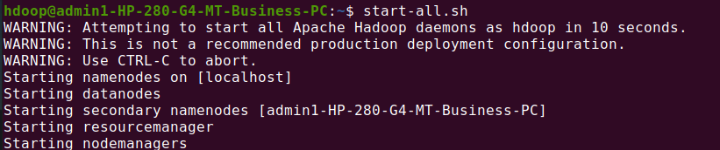

1. **Using jps command to list the to find the class name and arguments passed to the main method**

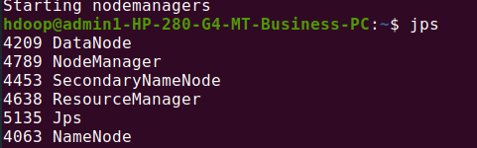

**The hadoop fs shell command ls displays a list of the contents of a directory specified int ht path provided by the user.**



**Creating a new directory by mkdir file_name command:**

**Inserting 2 empty files into a sahana directory**

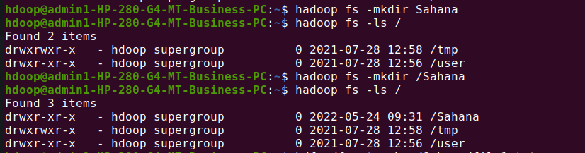

**Checking if the directory exits or not .**

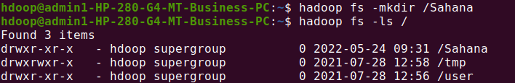

**Creating one more directory by usn.**



**copyFromLocal or put command is used to transfer put command can copy single and multiple sources from local file system to destination file system.**

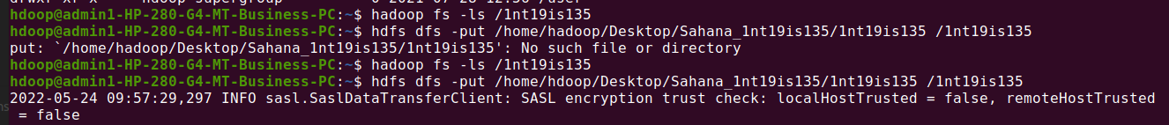

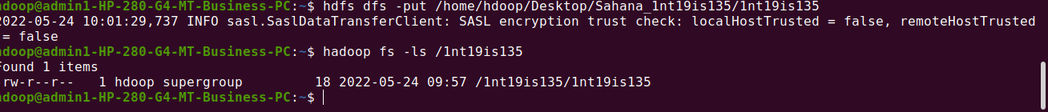

**Get :The Hadoop fs shell command get copies the file or directory from the Hadoop file system to the local file system**

